External Contractors and Telecommunications Service Providers Installation and Access Guidelines

Dulles Station East
a KBS property

2303 Dulles Station Boulevard
Herndon, Virginia 20171

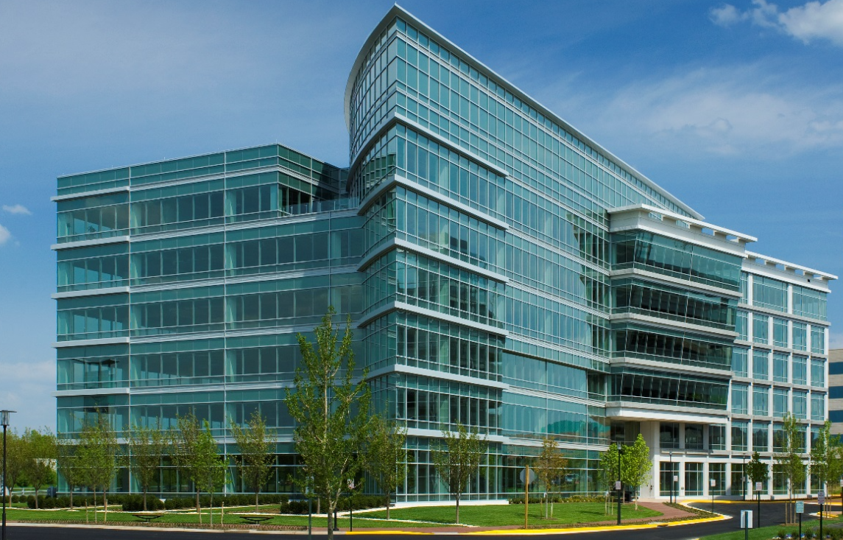

The purpose of this document is to provide information to contractors and building occupants about our building vendor standards, tenant connectivity guidelines, and services within the building’s riser. This document also sets the standards for the installation and abatement of riser cable and equipment at Dulles Station East. It is not intended for this document to replace the standards set forth in the Building Rules and Regulations. Rather, this is a quick overview of our building vendors standards and tenant connectivity guidelines. All documentation generated through these standard processes shall be the sole property of the building and shall remain within the building for future reference.

Building Directory:

Carla Hyatt
Property Manager
(703)448-0392
Carla.Hyatt@Transwestern.com

Lee Ann Taylor
Property Administrator
(571)326-1599
LeeAnn.Taylor@Transwestern.com

Walter Chavez
Chief Building Engineer
(703)793-0539
Walter.Chavez@Transwestern.com

Thien Nguyen
Engineer
(703)793-0539
Thien.Nguyen@Transwestern.com

Building Directory:

2303 Dulles Station Boulevard
Herndon, Virginia 20171

Dulles Station East Access Procedures

General Access:
Buildings are on restricted access on weekends and holiday. Access card is required.

Management Office Hours:
Monday – Friday
8:00 AM-5:00 PM

Building Hours:
Monday – Friday
7:00 AM-6:00 PM

*Please note that the loading dock is used for active loading/unloading only. After completing the loading/unloading process, vehicles should be immediately removed from the loading dock. Parking is available in the parking garage. The loading dock is frequently used daily during business hours for deliveries.

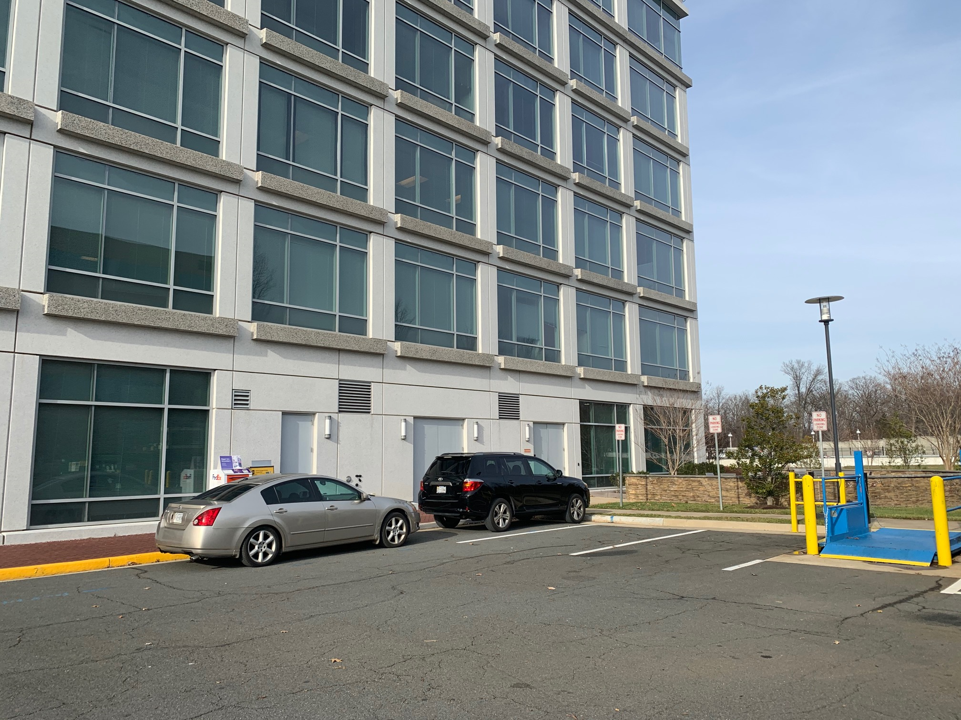

Loading dock reservation must be made with the Property Management office 24-hours in advance of scheduled use. If you are doing work onsite and need to use the loading dock and freight elevators, it must be reserved beforehand to ensure availability. We must ensure that any contractors, including sub-contractors, support personnel, or any other service personnel, have their current Certificates of Insurance (“COI”) on file. All scopes of work must be submitted and formally approved by management prior to arriving onsite. You must submit your COI to the Property Management Office for approval.

When you contact the Property Management office, please provide the following information and we will send you the appropriate Certificate of Insurance requirements.

The required elements should include:
- Company name
- First/last names of all participants
- Date and time of arrival
- Vehicle license plate (one per company)
- Purpose of the work
- Type of work that will be conducted
- Estimated time needed to complete work
- Affected locations for the work
- Access requirements
- First/last names + contact information of the field engineer on-site

Operations and Installation Procedure in the Building

Outline the process for obtaining approval to conduct installations within the building
- All scopes of work must be submitted and formally approved by Property Management prior to arriving onsite. You must submit your COI to LeeAnn.Taylor@Transwestern.com for approval.
- All core drills within the building require x-ray scan and approval from the base building structural engineer, Fernandez & Associates. Contact information provided upon request.

Outline Building Access Restrictions
- 24 hours’ notice required for freight and loading dock access
- All tradesmen shall enter loading dock only
- Equipment installations can be completed during normal business hours. Any drilling or loud work must be completed before 7AM or after 6PM M-F or weekends.
- Engineering coverage must be provided for all work completed outside normal building hours. Engineering rate if $75/hour with a minimum of 4-hours.

Tenant Access Restrictions
- Riser closets for the building are located within tenant suites on floors four, five and six, tenant approval is required 24 hours in advance of site access. Riser closets on floors one, two and three are in common spaces but are secure so please also give 24 hours advance notice as well.

Technical Information

Points of Entry:
The main point of entry is located on Sunrise Valley Drive at the east corner of the building. There are ten (10) 4” conduits entering the building.

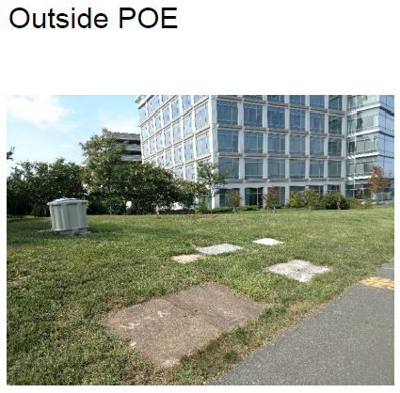

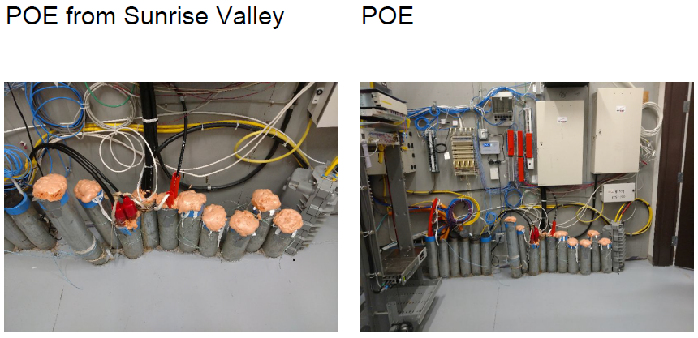

Basement Schematics:
Dulles Station East’s Main Telco Room is located on the first floor near the loading dock mechanical area. The room is starred in red on the below diagram.

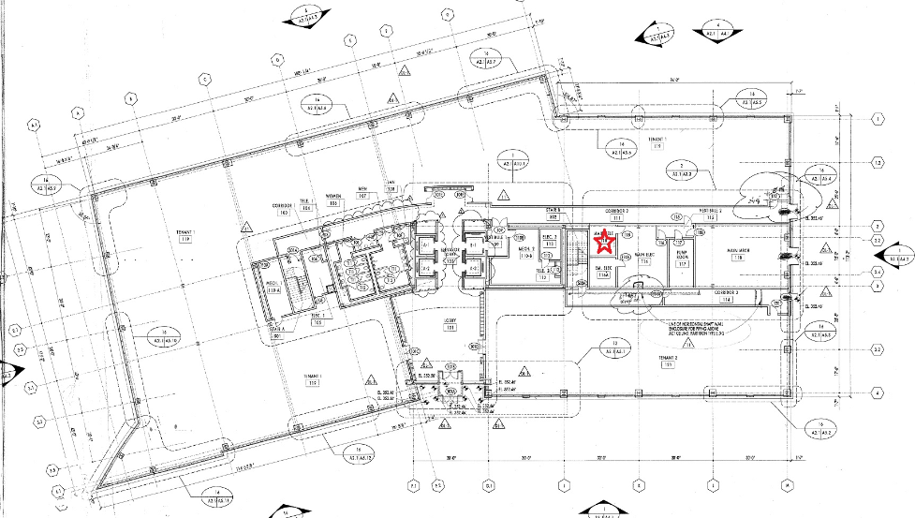

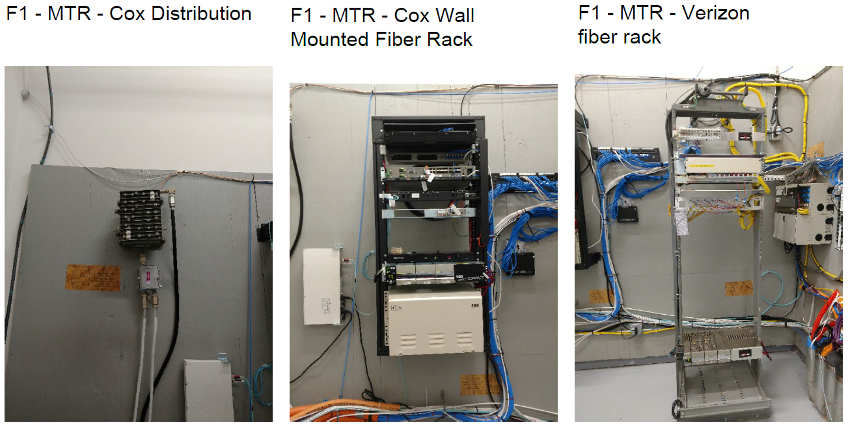

Horizontal Pathway Specification:
The path from the Point of Entry runs in conduits that pass under the concrete slab from the main telephone closet to risers A and B.

Telecom Equipment Room Specifications:
Riser closets for the buildings are centrally located in the core of the building. Closets are secure and can only be accessed by authorized personnel.

Riser Stack Plan:
All riser rooms are stacked directly above each other with no offsets. They are starred in red on the below diagram.

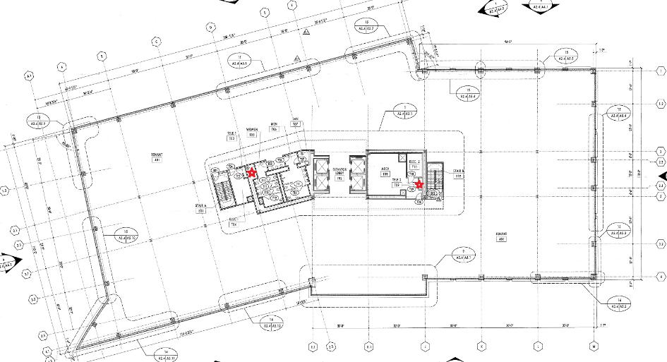

Riser Specifications:
All cables must be labelled throughout the riser for identification. Any core drilling must be approved by management and the building structural engineer. Six (6) 4” conduits from the main telco room to risers A and B.
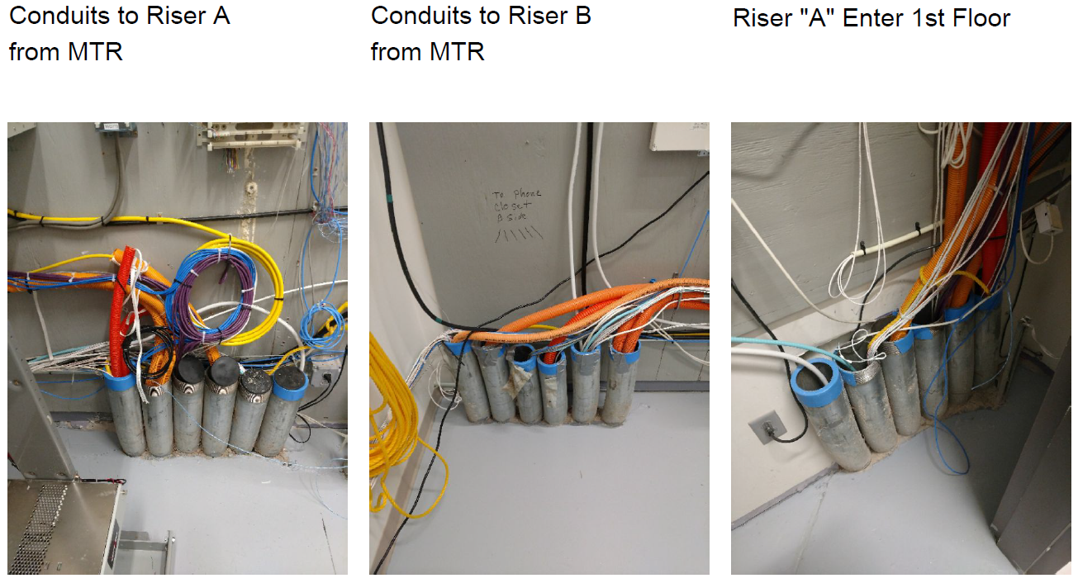

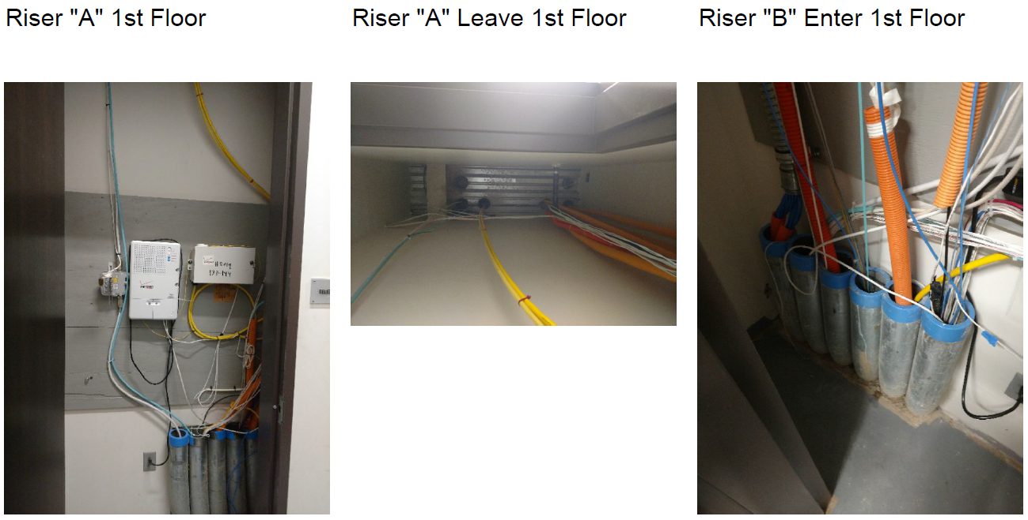

Specifications for cable runs from the riser:
Cable must be plenum rated and securely hung by hangers.

Installation Codes:
Cable must be plenum rated and securely hung by hangers.

Project Closeout Requirements:
- Once complete full as-built drawings must be submitted to property management
- Contractors are to take all waste materials with them and properly dispose.
- Contractors must maintain cleanliness and repair any damages to floor and/or ceiling tiles.

